**Project Development Phase**

**Delivery of Sprint - 2**

|  |  |
| --- | --- |
| **Date** | 30 October 2022 |
| **Team ID** | PNT2022TMID41712 |
| **Project Name** | AI-based discourse for Banking Industry |

# Creating Saving Account Action

Create a saving account in IBM Watson. Create new **Action** Saving.

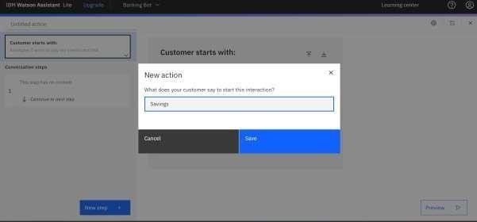

Add steps in savings action.

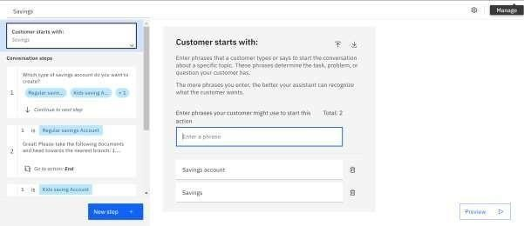

# Savings Account Action –Working in chatbot

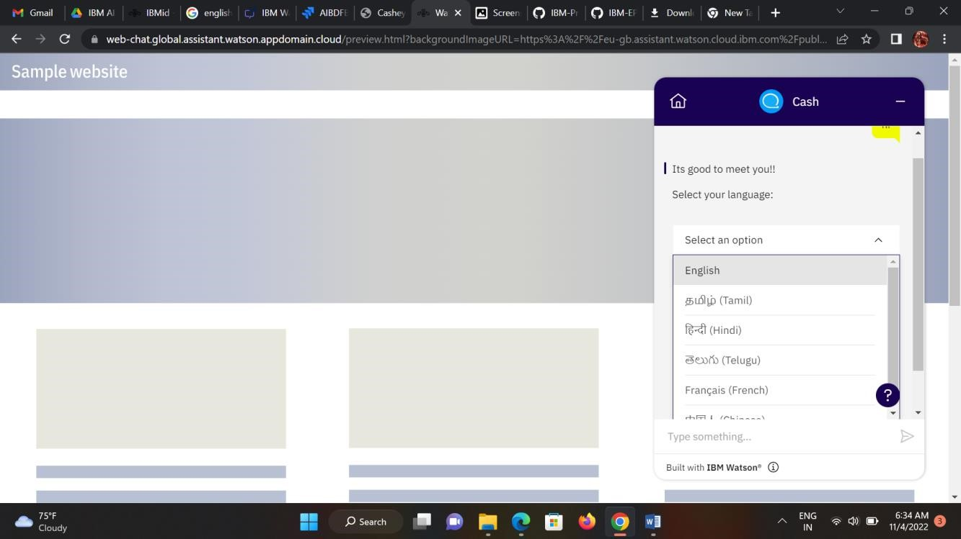

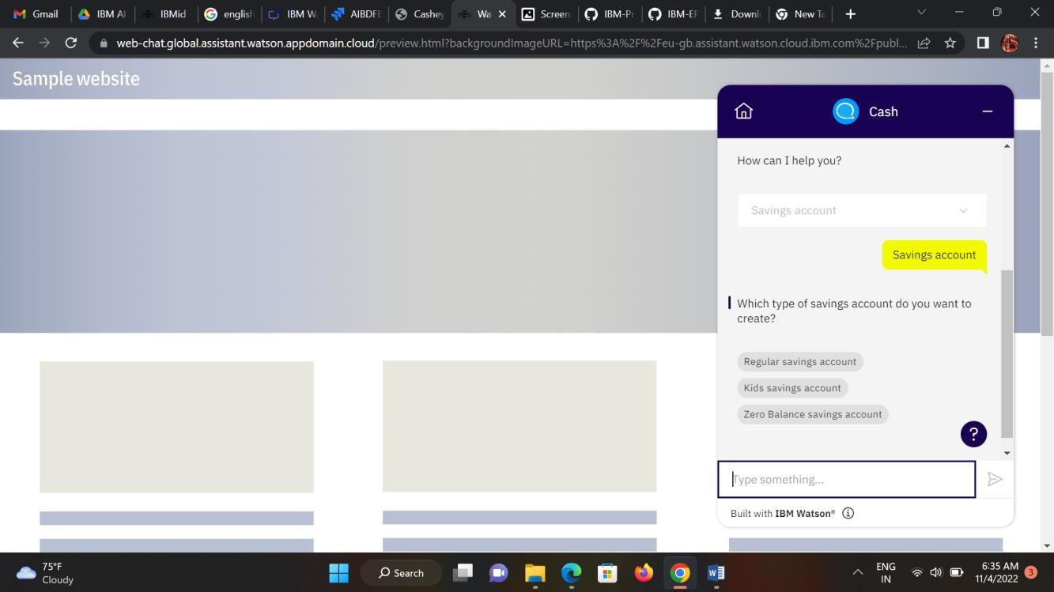

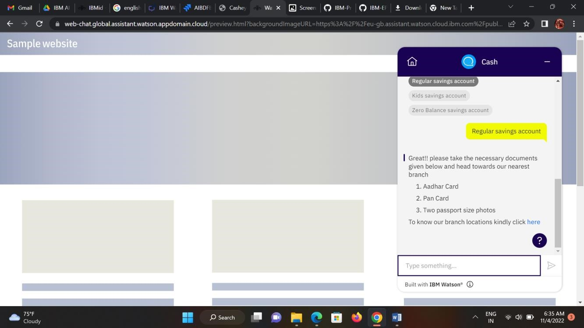

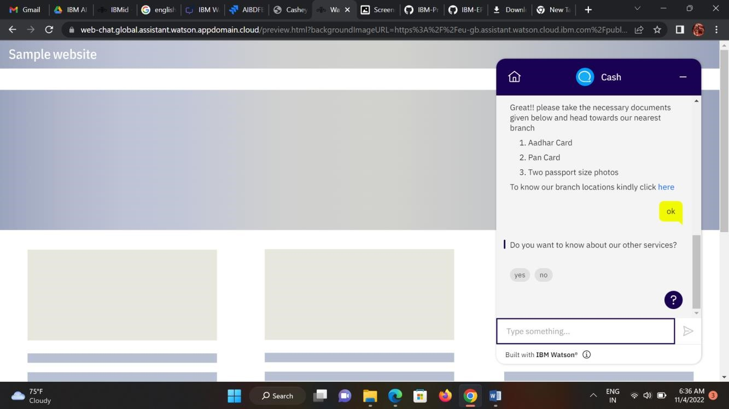

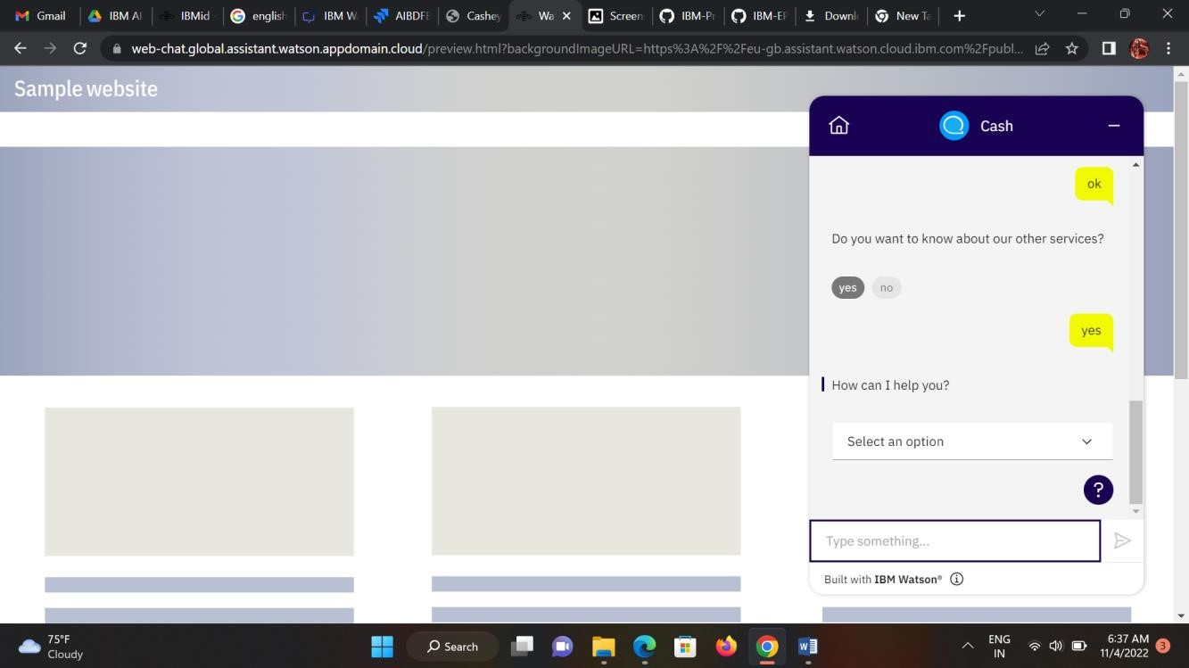

**Creating Current Account Action**

Create a new **Action** Current for the current account action.

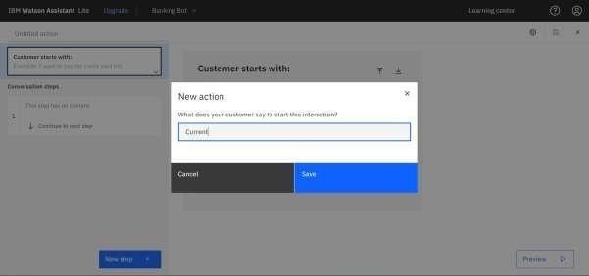

Add steps in savings action.

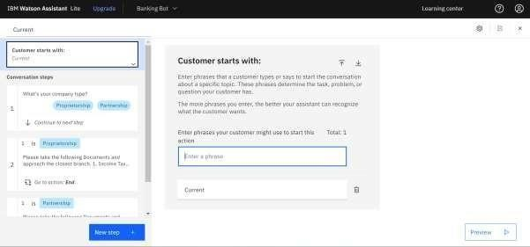

# Savings Account Action –Working in chatbot

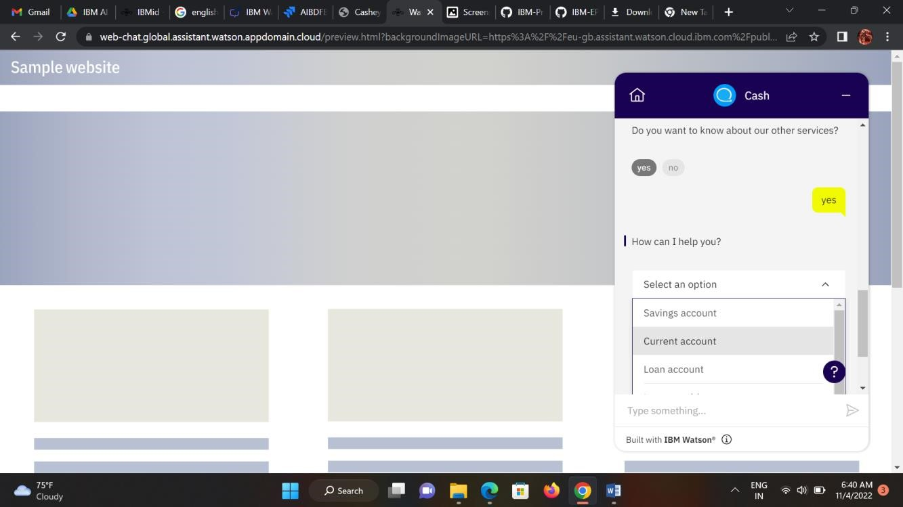

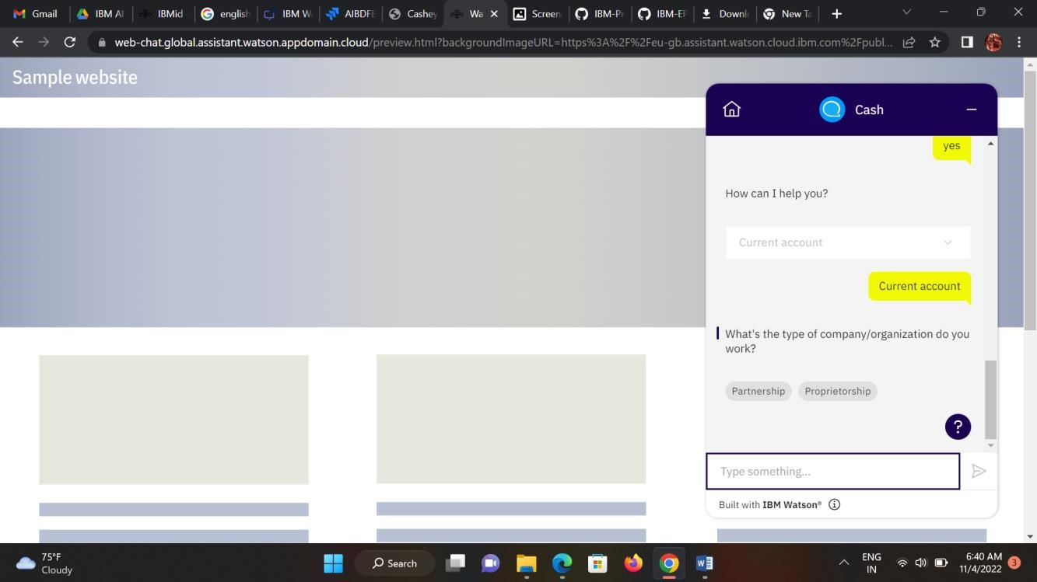

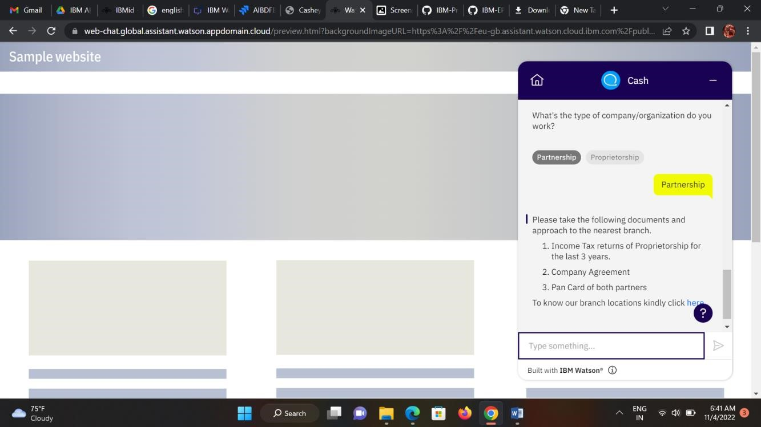

**Chatbot Web link:**

[**https://webchat.global.assistant.watson.appdomain.cloud/preview.html?backgroundImageURL=https %3A%2F%2Feu-gb.assistant.watson.cloud.ibm.com%2Fpublic%2Fimages%2Fupx-2b994459-**](https://web-chat.global.assistant.watson.appdomain.cloud/preview.html?backgroundImageURL=https%3A%2F%2Feu-gb.assistant.watson.cloud.ibm.com%2Fpublic%2Fimages%2Fupx-2b994459-1a5a-45a0-8955-89a6fd927161%3A%3Afc3fa4be-9ce8-4c04-ade5-6b159eba2610&integrationID=77c74feb-c1a6-4cac-85ff-d19401c2d534&region=eu-gb&serviceInstanceID=2b994459-1a5a-45a0-8955-89a6fd927161)

[**1a5a-45a0-8955-89a6fd927161%3A%3Afc3fa4be-9ce8-4c04-ade5-**](https://web-chat.global.assistant.watson.appdomain.cloud/preview.html?backgroundImageURL=https%3A%2F%2Feu-gb.assistant.watson.cloud.ibm.com%2Fpublic%2Fimages%2Fupx-2b994459-1a5a-45a0-8955-89a6fd927161%3A%3Afc3fa4be-9ce8-4c04-ade5-6b159eba2610&integrationID=77c74feb-c1a6-4cac-85ff-d19401c2d534&region=eu-gb&serviceInstanceID=2b994459-1a5a-45a0-8955-89a6fd927161)

[**6b159eba2610&integrationID=77c74feb-c1a6-4cac-85ff-d19401c2d534&region=eugb&serviceInstanceID=2b994459-1a5a-45a0-8955-89a6fd927161**](https://web-chat.global.assistant.watson.appdomain.cloud/preview.html?backgroundImageURL=https%3A%2F%2Feu-gb.assistant.watson.cloud.ibm.com%2Fpublic%2Fimages%2Fupx-2b994459-1a5a-45a0-8955-89a6fd927161%3A%3Afc3fa4be-9ce8-4c04-ade5-6b159eba2610&integrationID=77c74feb-c1a6-4cac-85ff-d19401c2d534&region=eu-gb&serviceInstanceID=2b994459-1a5a-45a0-8955-89a6fd927161)

**Note:** No code for this project. So, I attached the screenshot and step to build it.